Multiphone intercom
The Model MT-88 Commercial Telephone Entry System is designed for use as a primary access control device for apartments, condominiums, and offices with up to 200 residents.
The system can be used in a lobby or outside. Surface, recessed, and pedestal mounting options are supported. The system utilizes hands-free, full duplex telephone communications between visitors and residents for granting access.
Housed in a locked, rugged stainless steel faced enclosure, features a special designed lighted 12-key telephone style keypad and four operation buttons all with bright, easy-to-see graphics.
The backlit four-line directory LCD display scrolls a programmable welcome message and shows the directory Names and Directory Codes.
- Program type:
- Locally (keypad)
- Pc (Software send all information)
- Telephone
- Camera : 16:9, 100 degree with IR Board
- 199 visitor, future model with 399 visitors
- 199 code + 200 Proxy cards
- 12V ac / 12V dc

Features
- Big 4 line screen
- Many installation choices: surface, recessed, gooseneck
- Stainless steel front panel
- Lighted Keypad
- Accepts a total of 200 directory listings or stand-alone entry codes
- Four-line-16-character LCD display
- Removable terminal blocks
- 2 Relay
- Sound Voice instruction
- Works on the telephone line network
- No need for wiring
- Stand Alone System
- Proximity Card
- Program by :
Computer software / USB / keypad

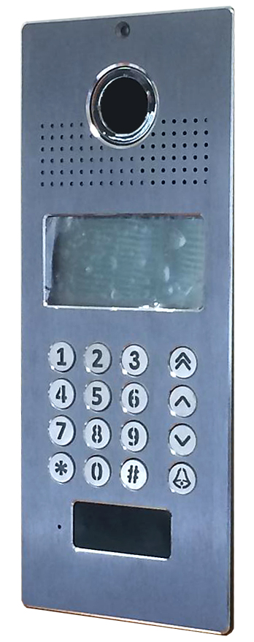

Please read the instructions before using

- Unit Operation.
- Features.
- Benefits.
- Specifications
Power Requirement | 12Vdc , Possible use 12Vac  ( preferred use 12Vdc to maximum performance)
Signaling | DTMF
Connection Port | Telephone line
Release contacts | Relay NO / NC
Panel Construction | Stainless Steel Faceplate
Back box | aluminum box
Surface Mount | 215(H) x 115(W) x 35(D) (mm)
Flush mount | 215(H) x 115(W) x 35(D) (mm)
Warranty | 12 months return to base

- Installation Drawing.

- Programming – there are 2 programming modes to Tador system.
- Technician Programming.
- End user Programming.

- Technician Programming.
- Enter Technician Programming
To enter Technician Programming mode do following steps
*
- Enter the Technician code ⇒ 123456 (by default) from left to right (Do not forget to enter the asterisk (*) after the password!).

- Technician Programming procedure.
- As long as Technician Programming mode is active, you can setup the unit parameters.
- You can browse through the menus using the arrow ( , ).
- To enter menu press the Bell (Bell) sign.
- To return Prog. Menu press the pound (#) sign

- To exit Technician Programming mode.
- When standing on the Prog. Menu mode Press on the pound (#) sign.
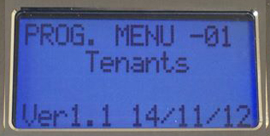

- "Set Tenants" (Main Menu)
on this menu you can set new tenants name,
it is possible to set up to 200 residents.
- To set new name use the keyboard buttons.
. - ,
1
A,B,C
a,b,c,2
D,E,F
d,e,f,3

M,N,O
m,n,o,6

J,K,L
j,k,l,5

G,H,I
g,h,i,4

W,X,Y,Z
w,x,y,9

T,U,V
t,u,v,8

P,Q,R,S
p,q,r,s,7

#
Forward
0
, (, )
Back
*
- Select the apartment number you want to set
(Use the arrows , ).
- Click on a certain number several times to
reach the wanted sign.
Example: 333 = F, while 333333 = f
- At the end of the signal has to pass the cursor
forward or backward.
- Pound (#) – Forward
- Asterisk (*) – Backward
For example, to set the name John Smith
- ⇒ 5#666666#44444#66666#0#7777#6666#444444#8888#44444#
Second example: Oren Twena
- ⇒666#7777777#33333#666666#0#8#99999#33333#66666#2222#
- To return to Prog. Menu press the asterisk (*) sign
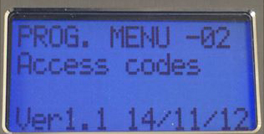
- "Access Code" (Main Menu)
On this menu you can set the entrance access
code, it is possible to set up to199 access code.
- To set a new code Enter between cells 01-199.
- To delete a code, select the code and press asterisk (*) sign.

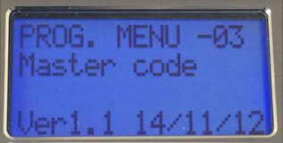
- "Master Code"(Main Menu)
Master Code is made for the technician
and allow full control over the unit
( full setting programming )
with the Technician code you will be able to
enter Technician programming mode, enter the
Technician password in the next format - password - do not forget to enter asterisk (*) after the password.
The Technician code 123456 by default and can be changed.
*
*
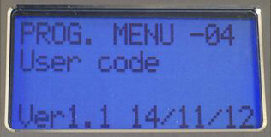
- "User Code" (Main Menu)
made for the end user (tenant) it let the tenant
to set names of tenets and access codes.
Enter the end user code in the next format – password .
*
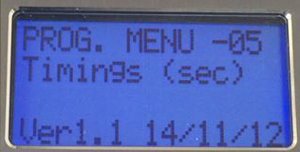
do not forget to enter asterisk (*) after the password. The end user code 252525, by default and can be change.
- "Timings"(Main Menu)
On this menu the different time modes can
be set for the unit

- "Delay Time"(Sub Menu)
The time that passes since you type
authorized code until the lock opens.
Daly time is 00 (0 seconds) by default and can be changed.
Delay Time
00
- "Door Opening"(Sub Menu)
let you set the time that the lock will
remains open.
Lock time is 05 (5 seconds) by default and can be changed.
Door Opening
05

- The unit have two relay that can be program below menu will let you set timing for the 2nd relay:
- "Relay2 dly time"(Sub Menu)
The time that passes since you type
authorized code until the lock opens.
Daly time is 00 (0 seconds) by default and can be changed.
Relay2 delay time.
00
- "Relay2 opn time"(Sub Menu)
let you set the time that the lock will
remains open.
Lock time is 05 (5 seconds) by default and can be changed
Note: If install 2 locks, Set setting in menu number 10 relays control.
Relay2 Open time
05
- Relay 1 - set access code for first lock. 0-144. (0-70).
- Relay 2 - set access code for second lock. 0-144. (70-140)
- Relay 1+2 - set same access code to both locks. 0-144. (0-140).
- "Illumination"(Sub Menu)
set the amount of time that the display will be
illuminated since the last touch typing.
Illumination time is 99 by default and can be change.
Illumination
99
- "Ringing Time"(Sub Menu)
Set the LCD illumination time while call is
made to a certain apartment, Max time 15 sec.
* The panel has two modes for ringing which
Ringing Time.
05
& Ring Name Dsp
- "Speech/Cam Time"(Sub Menu)
speech and camera time available until an
automatic disconnection of the call will be
made by the unit.
Speech & CAM time is 05 Sec by default and can be changed
(max 15sec).
Speech/Cam Time.
30
- Pin + Proxy Time"(Sub Menu)
Pin+ Proxy time
30
- "Door forget>Mes"(Sub Menu)
Set the time that in case the door remain
open panel will talk a voice message remind
you to close the door
message open door time is 40 by default and can be change.
Open Door
Message 40

- "Det>welcome Mes"(Sub Menu)
you can connect a detection sensor to the unit.
When a person approaches the panel the
detection sensor will be activated and it will run a voice message.
Detection Sensor
40

Detection Sensor time control the amount of time that the unit will respond to the sensor detection
detection sensor time is 40 by default and can be changed.
Defined time is X will be divided by 4 [ ], A value of 0 will be replaced by 1.
T.to name annou
08
1/4 sec base
X
4
- "T.to name annou"(Sub Menu)
the unit allows to record name of tenant and
once browsing between the names recorded
voice name massage will be played by the unit.
This function states amount of time since you have finished browsing between names that the unit will play the tennat names
Tenant Voice Message time is 08 by default and can be change. Defined time is X will be divided by 4 [ ], A value of 0 will be replaced by 1. (Set on menu 15 vocie message)
X
4
- "T.to floor mes"(Sub Menu)
after tenant will open the door a voice message
will be played saying which floor the tenant
stay.
This function states how much time after the tennant has open the door for the message to be played
T.to floor mes
12
1/4 sec base

Tenant Voice Message time is 08 by default and can be change. Defined time is X will be divided by 4 [ ], A value of 0 will be replaced by 1. (Set on menu 15 vocie message)
X
4ozforex.com.au

T.to floor mes
12
1/4 sec base

- "T.to Disp. List "(Sub Menu)
Set the time that list of tenants will be shown and
remain active after the time will pass unit will
return to main screen :
"Use arrows to search name. Enter app number then press bell" Message time is 40 by default and can be change.
Defined time is X will be divided by 4 [ ], A value of 0 will be replaced by 1. (Set on menu 15 vocie message)
X
4ozforex.com.au

- "T.todisp selected"(Sub Menu) –
The Time that the selected will appear.
0Display selected time is 06 by
Display List Time
06

default and can be change. Defined time is X
X
4ozforex.com.au

will be divided by 4 [ ], A value of 0 will be replaced by 1. (Set on menu 15 vocie message)

- "T.2cler select"(Sub Menu)
The Time that the selected
Display List Time
06

will appear. Display selected time is 06 by
default and can be change. Defined time is X
X
4
will be divided by 4 [ ], A value of 0 will be replaced by 1. (Set on menu 15 vocie message)

- "Talk Time X 105"
Set the talk time channel to remain active,
when the channel Inactive the call ends.
Talk time is 03 by default and can be changed.
Time is multiply by 10. [X*10]
talk time X 10
03
Min Value 1

- "Busy & Dial time"
If the desired number is busy the unit will
make a call back.
Talk time is 00 by default and can be change.
Talk Time X 10
00

- "Confirm Tone TM"

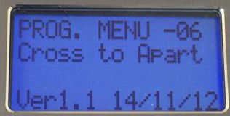
- "Cross to Apart"
On this menu you can set that ringer 1 instead
of dialing to apartment 1, will dial to
apartment X.
For example ringer 1 dials to apartment 10
CrossTo App#10 : 1

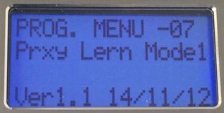
- Prxy Lern Model 1 / 2
On this menu you can set the Proximity cards,
you can set up to 205 cards in any menus 07
and 08. To set proximity card Follow the next setps
- Chose one of the tabs.
- Press the asterisk sign.
- Attach the proximity card to the proximity display.
- Successful action sound will be heard.
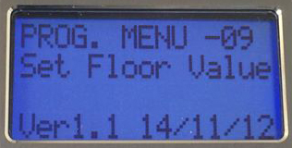
- Set Floor Value – On this menu you can set the
amount of apartments in the same floor.
(You can determine the amount of different
apartments on each floor).
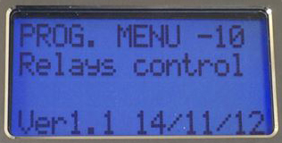
- Relays Controls – On this menu you can set the
Relays 1&2 to open the locks.
Relay 1 - will open tabs up to 199. (Default 199)
Relay 2 - will open tabs from 01. (Default 01)
Relay 1+2 – To open both of the locks at the same
time. There is to set the tabs to be overlapping
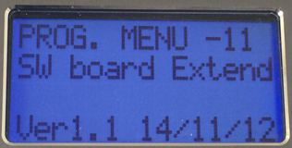
- SW Board Extend –
It is possible to add calling cards to the unit, each
calling card have 8 buttons that can be programmed
to call different apartment number.
Buttons in the calling card will be matched according
to the order that programmed in the unit in menu 21 - 26
example:
button number 1 will call telephone number 1.
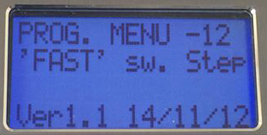
- 'FAST' sw.Step
this menu allow to program the fast forward button
How many names it will skip when pressed
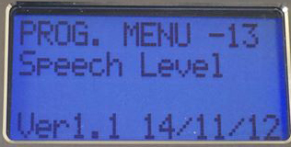
- Speech Level
allow you to set the speech level volume
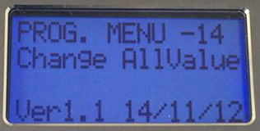
- Change AllValue
In this menu you can delete information from the
unit, 3 modes are possible to choose:
A. Erease all code
B. Erase all Prxy1 :
C. Erase all Prxy2 :
D. DEF !Names stay :
restore the unit to default but will keep the programmed names
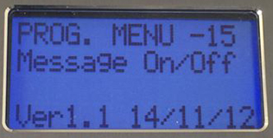
- Message On/Off:
unit can be programmed to talk with the user.
in this menu you will be able to set what messages
the unit will speech to the user or not.
A. Entry message:
unit will tell hello message when visitor enter the building.
B. Stage message:
unit will state floor number of each apartment
C. Close door Mes:
D. Names Announce :
E. Door forget Mes:
F. Welcome by Det:
G. Ringing Mes.:
H. Open door Mes:
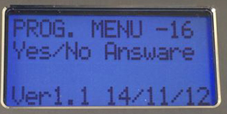
- Yes/No Answare :
Allow you to set additional setting for the unit :
- replacapp>Office : allow you to choose what will
be written on the first menu it is possible to
choose between office mode and app mode
if type 0 = will show: App number
if type 1-9 = will show: Office no
Det Active B.L?
If you want that the unit monitor will be lighted from sensor, once sensor will see the visitor the unit monitor will lighted up
- Proxy 1 -> Rly 1 : Proxy number 1 will open relay number 1
- Proxy 1 -> Rly 2 : Proxy number 1 will open relay number 2
- Proxy 2 -> Rly 1 : Proxy number 2 will open relay number 1
- Proxy 2 -> Rly 1 : Proxy number 2 will open relay number 2
- Proxy + PinCode : Set security that if want to enter the building will require Pin Code + Proxy Card
AppName by A-B : Set unit to order and show names by ABC or By number:
N = numbers.
1-9 = ABC
* after choosing an option you will have to enter tenants menu -01- and exit the menu so unit will organize the names
- Extrrnal Proxy :
if client want to install his own proximity sensor
- Elevetor Board :
Elevator board is used in case that you want the unit to invite the elevator once client enter the building.
- Realt.C. useed : unit have the possibility to show time if type:
1-9 : Yes (show time)
0 : No (Don’t show time)
- Show tel data :
- Beep in unlock :
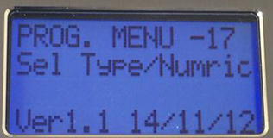
- Sel Type/Numric + New App numric :
Allow you to change modify the number
of the apartments / offices in the unit, there
are three possibilities:
A. Regular numbering, type: 0000/1
B. Start from specific number, means apartment number 1 will be named as 101, apartment number 2 will be named as 102. Etc..
If want to do that type : 0(Add Value) and number that apartment will start from 100
Example : 0100, unit apartment numbers will start from 100
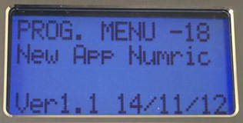
C. Custom mode :
custom mode will let you change specific apartment number to different number that you choose while all other will stay the same example :
Apartment number 7 will be 777
Type : 2 , exit menu and go to :
New App numric menu
here you will choose which apartment name
to change:
app. Number# 07
Type : 777
will modify apartment number 07 to 777
- Service Menu
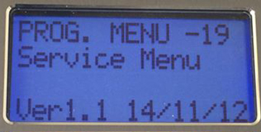
This menu will store details about fixes and
repairs that have been made to the unit by
Tador.

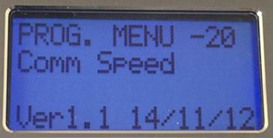
- Comm Speed
The MT-88 is able to work with Tador
Analogue IP monitors.
This menu allows you to decide what
communication between the monitors and
the unit.
Some area have bad wires, long distance etc if that the case you will want to check the speed between the monitor and unit and see which one works better in correlation with the unit.
0 – Slow Speed: If bad wires, long distance between unit and monitor
1 – Normal Speed: regular
2 – Fast Speed: If Good wires are used and not long distance.

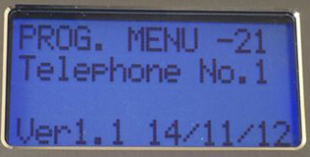
- Telephone No.1 – Telephone No.3 :
The unit has 3 telephone numbers in memory
this way when call is made from the unit, it
will first try number 1 telephone, if there is
a busy tone it will try telephone number 2,
if there is busy tone on telephone number 2 it will try telephone number 3.
For each apartment / office can be 3 regular telephone numbers
24. Telephone No.4 – Telephone No.6 :
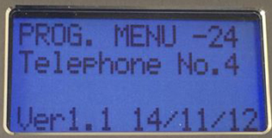
The unit has watch and timer inside.
This timer allow the unit to call certain
telephone number on specific day and time
for each apartment / office can be 3 special
telephone numbers
For example, during Sunday to Monday from 10:00 AM -> 15:00 unit will call on the first programmed telephone number (Telephone No.4) if there is busy tone it will try Telephone No.5 if there is busy tone again unit will call Telephone No.6.
For setting Watch time go to menu 31.
For setting Timer time go to menu 32.
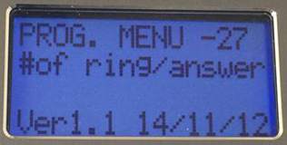
- #of ring/answer
In this menu you can choose how many times
the unit will ring
- Enter Busy Call
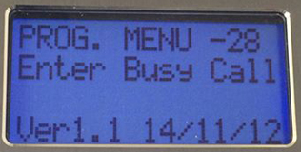
Usually busy tone is identified by the unit, but
in some cases there is different busy tone, this
menu allow you to set the unit to detect
different type of busy tone.
Busy tone Type1
Busy tone Type2
Busy tone Val.
Busy tone Freq
Call low Freq
Call high Freq
Break on call
Call to pass
No of bussy til :
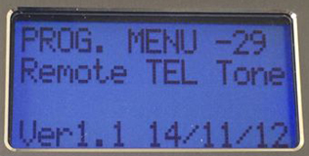
- Remote Tel Tone
This menu state which number will be used
to open the door from the telephone
- Confirm by Tone
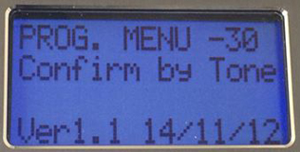
If apartment have answering machine and
client don’t want the Door entry to leave to be
able to leave a massage on the answer
machine.

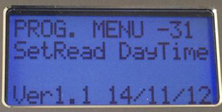
- SetRead DayTime
In this menu you will set watch time, watch
will be shown at the LCD screen and will be
used for the timer to call specific telephone
numbers during time and date that you choose.
D | HH | MM | Result
2 | 13 | 32 | 13:32 Monday
3 | 13 | 32 | 13:32 Tuesday

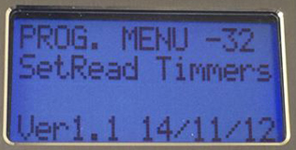
- SetRead Timmers
Timer1(DIAL) Da
TimerNO.1 Start
TimerNO.1 Stop
Timer2(DIAL) Da
TimerNO.2 Start
TimerNO.2 Stop
Timer3(RLY1) Da
TimerNO.3 Start
TimerNO.3 Stop
Timer4(RLY2) Da
TimerNO.4 Start
TimerNO.4 Stop
- LCD Family No.
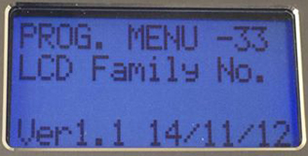

תודה על רכישתם ממוצרנו, חברת תדאור
טל - 03-9226351 www.tador.co.il
פקס - 03-9210461 www.tador.co.il
כל הזכויות שמורות לחברת תדאור ©

