General:
C-90
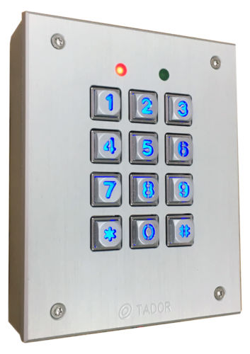
The C-90 encoder is a safe and comfortable
access control product.
Get an individual access code.
The device includes an environment resistant
An optional bypass pushbutton enables easy
Internal opening (the opening time is programmable)

Features:
Installation possibilities: on wall, under plaster, inside aluminum panel | Power failure resistance, keeps the access codes in nonvolatile memory
Easy installation, programming and operating. | Environmental and anti vandal resistance.
Works with AC or DC power supply | Up to 100 million possible combination codes
up to 98 simultaneously different access codes | optional bypass exit pushbutton
Different and programmable opening time from keyboard and bypass pushbutton

Specifications:
Operating voltage: AC or DC 12V 800mA | Code length: 2-6 keys
Operating electric or magnetic lock. (normally open or normally close) | Opening time: 1-9 seconds
Dimensions: Surface Mount: 110X100X35mm (H*W*D) | Flush Mount: 154X115X45.6mm (H*W*D)
Videx adapted 120X97X25mm (H*W*D) | Color: silver or bronze

Installation:
according to the door lock type,3 pins Jumper J5 should be set
Desirable RLY state when entering right code | Jumper J5
Close circuit (Normally open) for electric lock | Jumper on 2 right pins (default state)
Open circuit (Normally close) for magnetic lock | Jumper on 2 left pins
After installing the lock in the door frame. Route the following wirings to the C-90:
- 2 wires from power supply.
- 2 wires to the lock.
- 2 wires from optional bypass pushbutton.
Using Phillips screw driver open 4 top cover’s screws, carefully pull up the panel.
Using a screw driver, expose the 4 covered insulations bores and the round wirings bore.
Attach the base of the C-90 to the wall, using a pencil mark the 4 fixing points.
Drill the 4 fixing points on the wall.
Route the wires through the round bore in the base of the C-90.
Using 4 screws install the base to the wall.
Verify the power supply is not connected to power source!
Connect the wires to circuit board terminals according to the circuit’s labels, the attached electrical diagram and the following instructions.
Connect: Power supply to the two 12VAC terminals.
One wire from the lock to the RLY terminal. The second wire from the lock to one of 12VAC terminal. Short wire from the second 12VAC terminal to the second RLY terminal.
(the RLY functions as a switch)
- the polarity of the wires is non significant.
Reassemble the panel over the base.
Attach the top cover to the base using the 4 screws.
Connect the power supply to the power inlet, the red led will constantly illuminate, indicating power supply to the C-90. the green led will blink for 2 seconds indicating correctly initiation.
Programming:
100 memory cells 8 digits long each one, available.
Cell 00 is used for door opening times values storage.
Cell 99 is used programming code value storage.
The rest of the 98 cells from 01 to cell 98 are used for different access codes values storage.
Code length is minimum 2 digits and ,maximum 8 digits. (recommended 6 digits for programming code, and 4 digits for access code)
Programming code, access codes and opening times values are programmable via the keyboard.
Programming mode: in order to store new access code, set opening times or changing the programming code, you should enter to the Programming mode.
After clicking the valid programming code (manufacturer code if not changed is ⇒123456 confirm with*) the green led is blinking, now you can do the required programming as described in the following examples. When finished you can enter more access codes or exit this mode to the regular state by typing #.
Each key stroke is followed by a Beep sound, entering a false code or invalid typing is followed by a “Beep-Beep-Beep” sound sequence. Entering a valid sequence to memory cell is followed by a long “Beep” sound.
If the programming mode is not exit. A timer exits the C-90 from this mode to a regular mode.

Examples:

Storing a new access code
Enter the programming code: if not changed is: 123456 confirm with *, the green led will blink.
now the following sequence should be entered: memory cell number (2 digits), access code (2-6 digits),and for verification again the same memory cell number, the same access code. Confirm with *. To finish press: #.
You can add more access codes in cells 01-98 in the same way.
- to use the access code: press the access code followed by *.
Changing the programming code
Enter the programming code: if not changed is: 123456 confirm with *, the green led will blink.
now the following sequence should be entered: memory cell number 99 , new programming code ,and for verification again the memory cell number 99, the same new programming code. Confirm with *.
Now you can add access codes in cells 01-98 as described or exit.
To finish press: #.
You should keep this code because this is the only way to enter the programming mode!
Back to Initiate status – default
Using an internal jumper the initial programming code can be restored. The access codes will not be changed.
Turn the power off. dismount the panel. Install a jumper on pins labeled: DEFAULT turn on the power, a long “Beep” will be sound for confirmation.
Turn off the power and take out the jumper. Reinstall the panel.
The C-90 returns to normal condition. The Programming code now is: 123456 *.

Canceling an access code
A particular access code could be cancel if its memory cell location is known.
Enter the programming code: if not changed is: 123456 *, the green led will blink.
now the following sequence should be entered: memory cell number to cancel(2 digits), and # # .for verification again the same memory cell number, and # #. Confirm with *.
For example: canceling the code stored in cell number 37:
press the following sequence: ⇒ 37,# #,37, # # *.
To finish press: #.

Setting opening times values
A different opening time value can be set to opening via the keyboard and via the optional bypass pushbutton.
The times values are from 1 second till 9 seconds.
Enter the programming code: if not changed is: 123456 *, the green led will blink.
now the following sequence should be entered: memory cell number 00, opening time via keyboard (1 digit) followed by opening time via bypass pushbutton (1 digit). for verification repeat the same sequence of memory cell number 00 opening times values. Confirm with *.
To finish press: #.
Remark: when setting the keyboard opening time, a value to the bypass pushbutton must be set also, even if not installed.

Summery and examples
Programming option | execution | default
Entering programming code | ⇒ 123456 *
Changing programming code  For example: new code 777456 | Enter programming code *  ⇒ 99-777456 99-777456 * # | 123456
Storing a new access code  For example: cell number 01 access code: 2040 | Enter programming code *  ⇒ 01-2040 01-2040 * # | All the cells are empty  (not 0)
Canceling access code stored in cell number 37 | Enter programming code *  ⇒ 37-# # 37-# # * #
Setting opening time from keyboard to 2 seconds and from bypass pushbutton to 5 seconds | Enter programming code *  ⇒ 00-25 00-25 * # | 3 seconds from keyboard,  3 seconds from bypass pushbutton

operation

Opening the lock using the keyboard
Enter the access code confirm with *.
The lock will be open for the time value it was programmed.
Each key stroke is followed by a Beep sound, entering a false code or invalid typing is followed by a “Beep-Beep-Beep” sound sequence

When exit the secured room press the bypass pushbutton, the lock will be open for the programmed time value (could be set to different value than entering).

C-90 encoder Electrical drawing
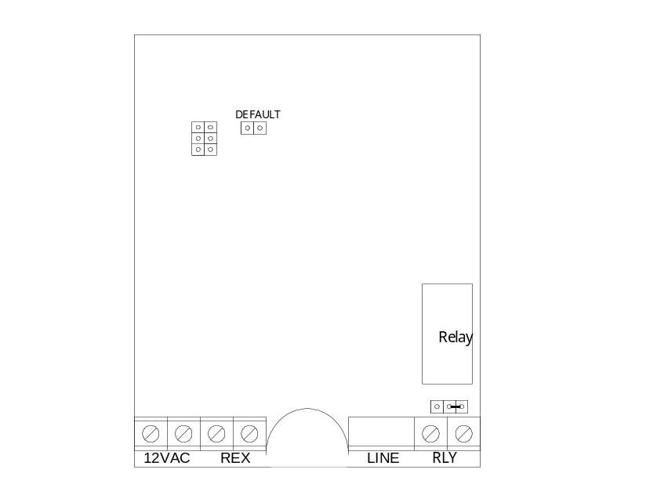
12VAC

Bypass pushbutton
Electric lock

RLY = Normally open
Jumper as in drawing

August 2004

